In this lesson we aret going to bringing a logo to work with

We are gonna animate it on the screen then have a background with it as well to create a nice inro or outro you could put on a Youtube video. For example

If you don’t have any logo go to pixabay and we can start typing in mountain logo

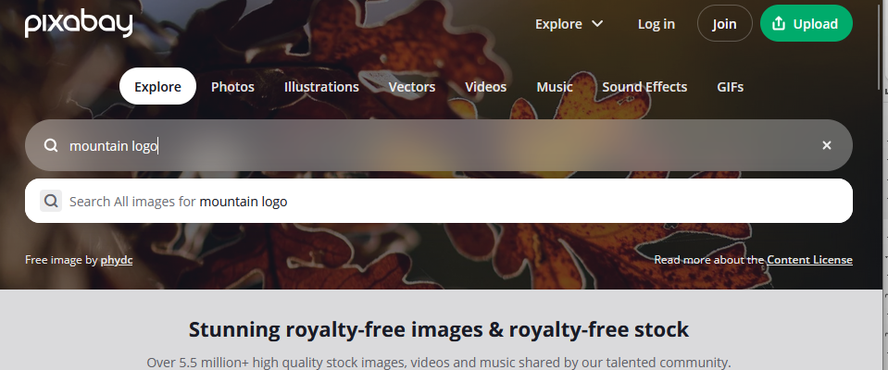

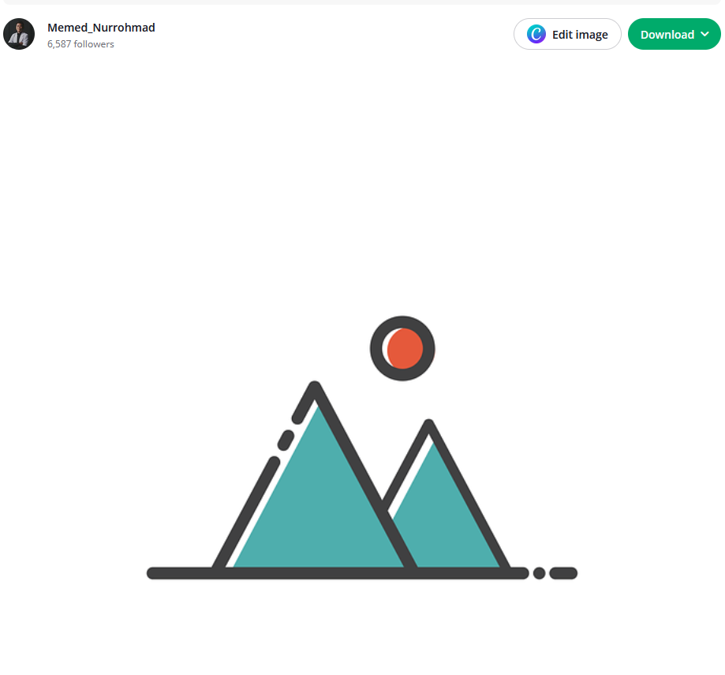

The above image we are going to use for our tutorial it is free to use and copyright free

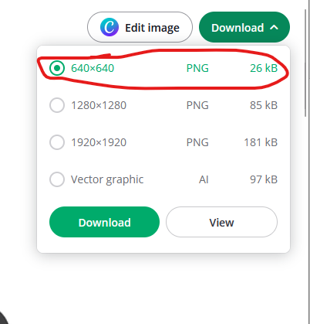

We choose the above marked resolution for downloading image

You can see our mountain logo image has complete white background so we are going to bring it into our natron and then remove the white background

You can instead of reading it into natron by read node you can drag and drop the image in node graph as shown below

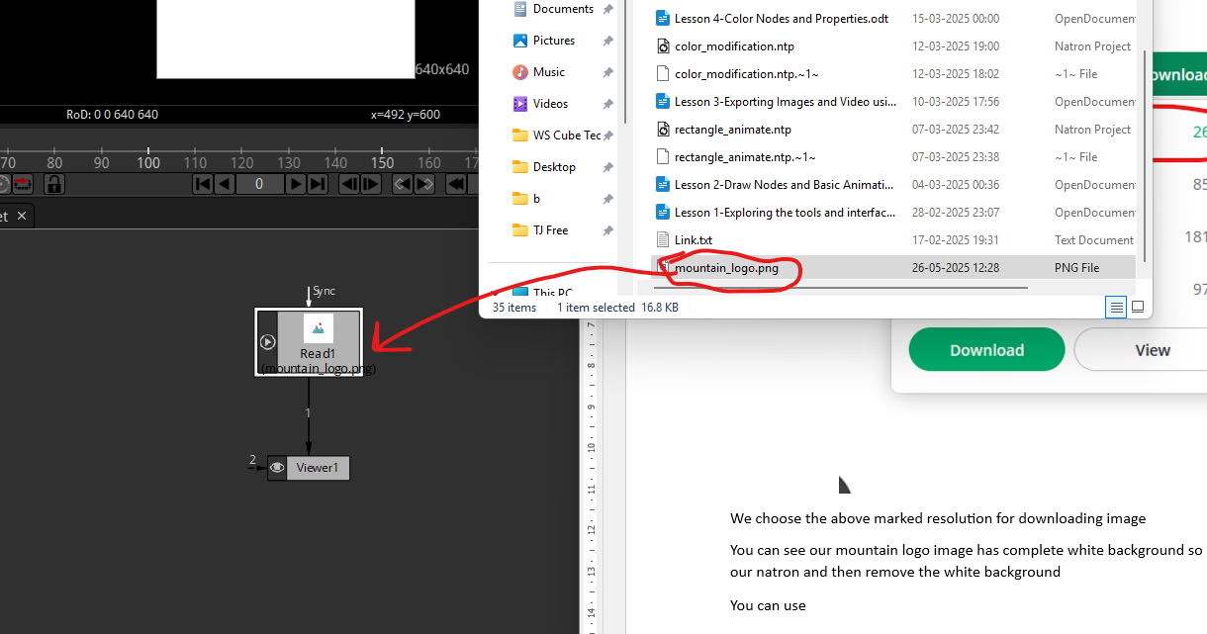

Now you can see above read node is connected to our viewer node and you can see that viewer tab our image is shown

Also since it is the first file we imported it changed our setting it was 1920 X 1080

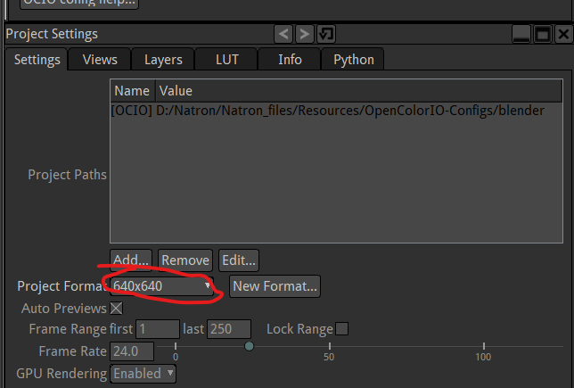

Now it is 640 X 640 as marked above because for all natron knows that this is like the final thing we are going to rendering out sp it dors not have any black space on the sides ,top and botoms(maybe because the images will be smaller than decided resolution of the video ) So it just thinks that but we want it to be 1920 X 1080 so lets change that

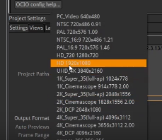

It does not look something has changed to the teacher or neither me

Maybe we will tell when we read in (I don’t know) So draw in our background now So we got to filter node and choose shader toy node

And for preset we go to source and then to Worley Noise Waters

So below is the background

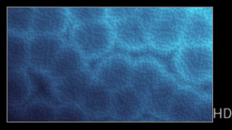

It looks like slight multiple disturb in the water as shown above

It is not a really video footage form a file Its actually different math and setting by coding

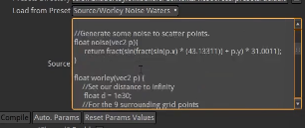

To create this animation or sort of like yeah a nice watery looking shapes but we want to see our logo on top of it So I am gonna break the pipe to our logo now from viewer and also break for ShaderToy and we will introduce Merge node and make the mountain icon as foreground and the eater shaderToy as background

__________________________________________________________________________________

**Note:-**

I think whatever resolution we choose in project setting is maximum frequency we can show our image

If I turn the project resolution less than image resolution then that part will be shown that come in that resolution part(I think so)

__________________________________________________________________________________

Now it the viewer will look like below

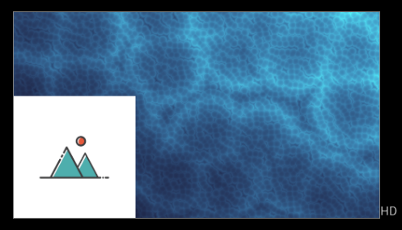

Now node graph will look like below

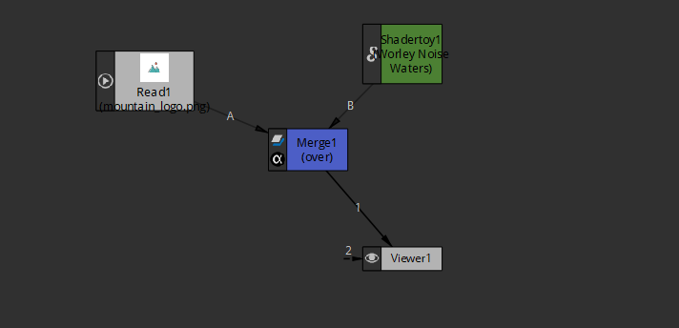

So we see we have shaderToy background going into merge node and logo going into the merge node coming out to the viewer node so now we lets move we cannot move anything in our viewer panel so if we want to move this logo we need to animate it or may we say transform node so while the logo node is selected if we hit the T key on our keyboard we can being in a transform node between the icon node and the node it was connected to. you can also add the transforms node by selecting the icon node and then choose the transform through transform tool. There is another way we can do so by selecting the icon node and then press tab key then this panel will come

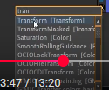

Now we type transform (I think it is shortcut way to access any node (who knows))

Now type the transform and then transform node will be added between the icon node and the previous connected node to it Mow once this transform is connected like below

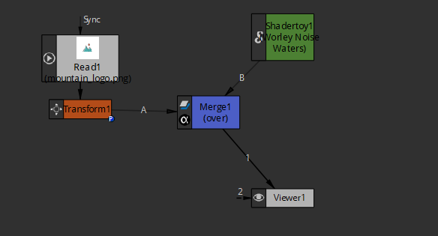

Now you can see there is a structure for handling it as shown below

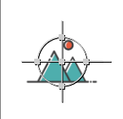

By dragging from center you can move it around

We move it around the center as shown below

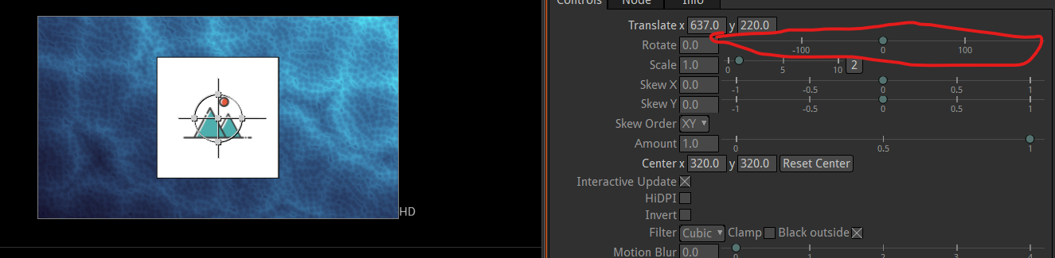

We can also scale it by dragging but we can also do so by using the marked one

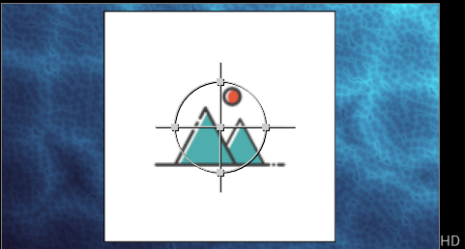

Now we have a logo as shown above except the major problem here is white background

We can go back to the source file open this up in gimp or photoshop that white background so that it become transparent that’s one option

If we were drawing this logo like in scape and just creating it from scratch we might have given a transparent background to start with but sometimes you just don’t have a transparent background so I will show you how to get rid of that we are gonna be using a keyer node to do that

4:35

In previous lesson we have learnt a keyer before

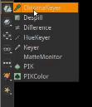

Now we have used the Chrome Keyer to remove the green and make it look transparent you can do it with a green or blue screen but we will just come down to the keyer and we are gonna add a keyer in line here so nothing changes so far

I have discovered that green or blue screen can be removed by chromeKey but I think other color can be removed by keyer node

Now the node graph will look like below

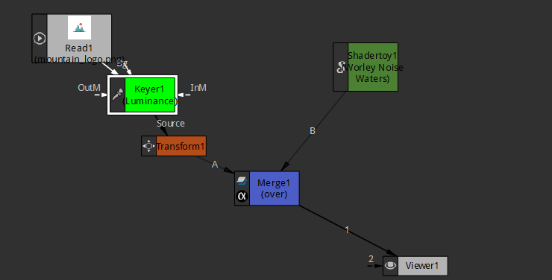

We will go over the settings of our Keyer node

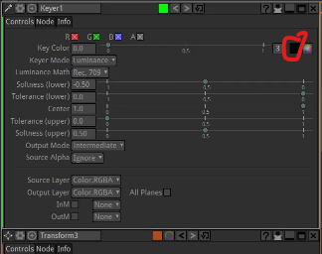

Now we go to Key color attribute and then choose the color picker as marked above we come over the background of icon and choose the background of the icon that is white and click on the white to pick it.

Before picking the color

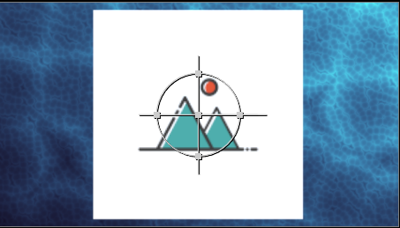

After picking the color

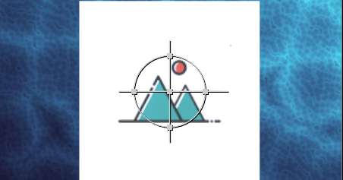

You can see that there is difference ( that is there is certain lightness ) in the viewer tab as shown above

We can change the keyer mode to screen ( I think by choosing a mode we are telling that on basis of what we will differentiate the different regions of the image that tell what region pixels to be transparent or what pixel be opaque here luminance is chosen maybe it will tell to differentiate region on the basis of luminance( maybe intensity) of a color ) we change it to screen (now differentiating on the basis of screen(who knows))

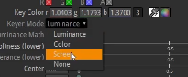

and change the output mode to Premultiplied from intermediate

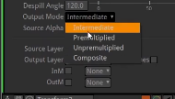

I don’t know what is happening here but I will research about it but it slightly replaces the background but not perfectly

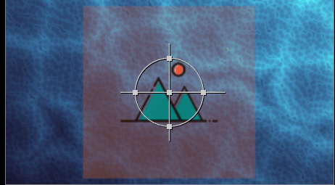

**Note:-**

By tab key we can open the search wizard to find the tools or feature and use it from there

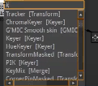

In my output there is redness remains instead of white background

We want to get red pixel out you see it not a perfect key for out removal of background

If instead of color picker we just choose only pure white in color chooser

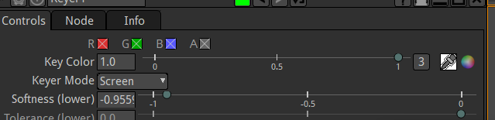

Now we will see white is removed properly

I don’t know what is happening but just for now think by this way the background will be replaced by choosing a color other than green or blue that is Keyer mode -> screen and output mode -> Premultiplier and choose the color

**Note:-**

Keyer has more features than ChromaKeyer

S by choosing white we get below output

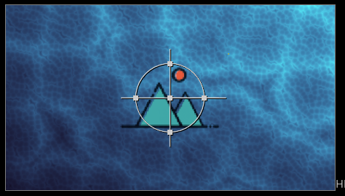

For some reason the pixel were not accurately white in the background image of icon so instead of actually keying and selecting since we know the background is white we just click on the white part of the color wheel otherwise if you chose some light color that is mixture of two color that includes white then one color would shine through like we were getting red hue coming through Now we can play and render this nice thing that alone could be a good logo I mean a good splash screen but If we want to do something differently we can add in some animation to this so let’s have it starting it from the bottom of the screen as shown below

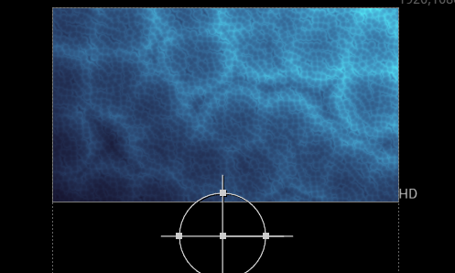

let’s do and let’s have it animate so from frame 1 and now double click on the transform node to see its properties on top on properties panel like below

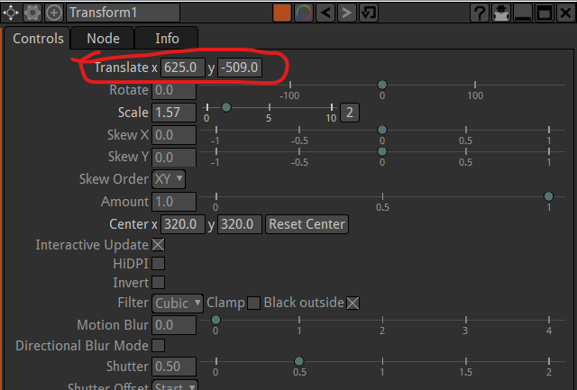

Now right click on the translate and then submenu will be opened

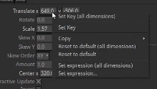

and now we clicked on Set key( all dimension ) now all field is turned blue In color means there is keyframe in that frame in timeline that is first frame as we are currently in it Now go to 30th frame

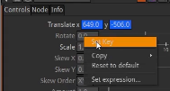

or even faster than that go to frame 15 (now the translate field is sky blue (means no keyframe there)) and then we move it to the center by changing the y position due to which the field is again blue in color means at 15 frame there is keyframe that represents change in the position

we can do other things like Rotation

now we right click on rotation and click on set Keyframe due to which the frame field will be in complete blue color in first frame



and then come at 15 frame and then here field will be in light blue color



now we set the value of rotate to 360 now our field will be blue in color meaning that at frame 15 the keyframe for rotation is set

Now our icon will come from bottom while rotating to middle of the screen and stops at the center of the screen and at that fully rotated to 360 degree and background is doing its things

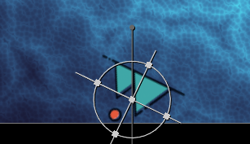

At frame 30 we could apply something else that we could apply somethine else like we could apply some other effect

At frame 30 we could do something like skew

When we get to frame 30 we will set a keyframe for the skew



And then reach frame 35



Now we set skew to -0.623



And now It is turned to blue color means keyframe at 35

Now move to frame 40



Now we set the field to 0



Now between frame 35 and 40 we see the effect such that it skewed and unskewed immediately

9:05

These are the things that you could do So we got a nice little thing we could also animate it off the screen

So we will go to frame 60 and then from there ( this is center of the screen ) add the keyframe on the y axis by right clicking on the y field and then in submenu we just click on set Key

Now it look like below

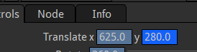

Now move to frame 70 and then make the y such that the mountain icon go out of the screen vertically we set it to 1000 Now it look like below



In teacher output when the mountain icon move upward the it speed get slowed when it reach the top maybe it is because older version but it is happening with him

So that’s an example of how you can do a splash screen using Natron

Teacher is saying that natron does not work with audio at all so what we do is render this out now

Now in project setting

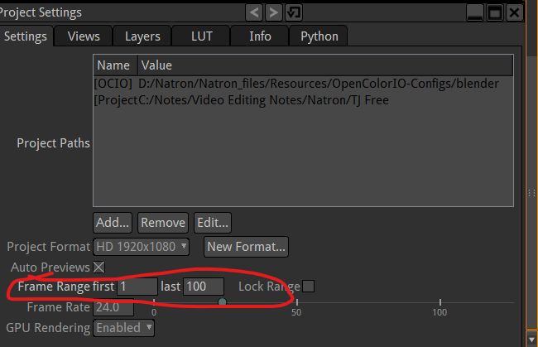

We set the last frame as 100 so the output will include 100 frame and you can see the change in Viewer window It includes 100 frame and then through writer we get the output

We call it intro.mp4

We just connect that writer to the last frame that is connected to the viewer node so that whatever we see in viewer node will be exported as an mp4 file in the location chosen inside the writer

The writer frame per second should match with frame per second of our project setting

The writer will render the whole entire project range

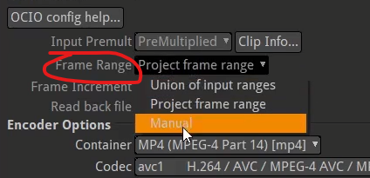

You can set the frame range that you want to output by going to frame range as marked above and then choose manual

If you choose manual then you need to tell what range of frames you want to see

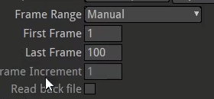

You can even just render an image ( most properly ) by setting first and last frame same telling of what frame image you want Keep the output format as jpeg, png or anpther image format

Now this file is what we will take to put it in video editor then apply some music to it or we can try this as an ending or beginning of a Youtube video. We just put it in our video editing software then at that’s point you throw in the audio and you add sound effects to all trandition of the icon animation